BanglishCheck
Explainable AI-Generated Text Detection for Banglish
Technical Report — Research Den Fall 2026 Technical Project
Najmun Nahar Hira
October 2026

Abstract
Automatic AI-text detectors are almost all built and tested on English, but a large share of everyday online writing in South Asia is Banglish: Bangla written in the Latin alphabet, often mixed with English in the same sentence, with no fixed spelling for the same word. This project, BanglishCheck, builds a detector for Banglish specifically, and treats explanation as a first-class requirement rather than an afterthought: every prediction comes with the words and writing-style signals that drove it, so a user can judge the score instead of trusting it blindly. A classical TF-IDF plus logistic-regression model, augmented with 14 hand-built Banglish stylometric features, reaches 96.5% accuracy and 0.996 AUROC on a held-out test set, matching a fine-tuned XLM-RoBERTa transformer while running on free CPU hardware and producing exact rather than approximate explanations. A deletion test confirms the explanations are faithful: removing the five words the explainer ranks highest drops model confidence three times more than removing five random words. A leave-one-generator-out test shows the detector's biggest weakness: accuracy drops sharply on AI writing from a model it was never trained on, which matters directly for how such a tool should and should not be used.

1. Introduction
Bangla speakers increasingly write online in Banglish — Bangla transliterated into Latin script, frequently code-switched with English within a single sentence or even a single word. This is common on e-commerce review sites, social media and messaging, and it has no standard spelling: the same word ("valo", "bhalo", "balo" — "good") can appear several different ways in the same dataset. Since large language models can now write fluent Banglish, there is a growing need to tell apart human- and AI-written Banglish text — for moderation, for academic-integrity checks, and for platforms that want to label AI-generated content.
Existing AI-text detectors are built and validated almost exclusively on English, and they generally give a bare score with no explanation. Applying an English detector to Banglish risks silent failure: the detector may be keying on surface patterns (spelling regularity, sentence length) that mean something different in Banglish than in English. A bare score is also risky on its own: a false "AI-generated" label can be used to wrongly accuse a real person, so a detector that cannot show its evidence is harder to use responsibly.
This project asks two questions. First, can a Banglish-specific detector, built with Banglish linguistic and stylometric features, reliably separate human- from AI-written Banglish text? Second, can that detector explain itself — at the word level and at the level of writing-style signals — in a way that is demonstrably faithful to what the model actually used, not just plausible-looking?

2. Related Work
AI-text detection is usually framed either as a supervised classification problem (train a classifier on human vs. AI examples) or as a zero-shot statistical problem (e.g. perplexity- or log-probability-based methods that don't require labeled AI text). This project takes the supervised route, using a classical TF-IDF + logistic-regression pipeline and a fine-tuned transformer as a point of comparison.
XLM-RoBERTa (Conneau et al., 2020) is a multilingual transformer pretrained on 100 languages including Bengali, making it a reasonable baseline for Banglish despite the latter being a code-mixed, romanized variety the model was not specifically pretrained on. For interpretability, this project uses exact SHAP values (Lundberg and Lee, 2017) for the linear classical model and Integrated Gradients (Sundararajan et al., 2017), via Captum, for the transformer. The deployed demo runs on Gradio (Abid et al., 2019) via Hugging Face Spaces.
The human side of the dataset comes from BanglishRev (Shamael et al., 2024), a large-scale dataset of Bangla-English code-mixed e-commerce product reviews — see Section 3 and the References.

3. Data
The dataset combines human-written Banglish product reviews with AI-generated Banglish e-commerce reviews from three generators:
Source | Texts | Notes
Human | 1,638 | Banglish product reviews from BanglishRev, posted before 30 Nov 2022 (ChatGPT's release)
ChatGPT | 783 | Generated Banglish e-commerce reviews
Claude | 667 | Generated Banglish e-commerce reviews
Gemini | 188 | Generated Banglish e-commerce reviews

- Reviews written in Bangla script, under 5 words, or over 60 words are removed.
- The human texts are sampled so their word-count distribution matches the AI texts', so the model cannot separate the two classes by length alone (see Figure 1).
- The data is split 70% train / 15% validation / 15% test, keeping each generator's share constant across splits.
- Human texts are dated before ChatGPT's public release so they cannot themselves be AI-generated.
- The raw data is not included in the project repository.
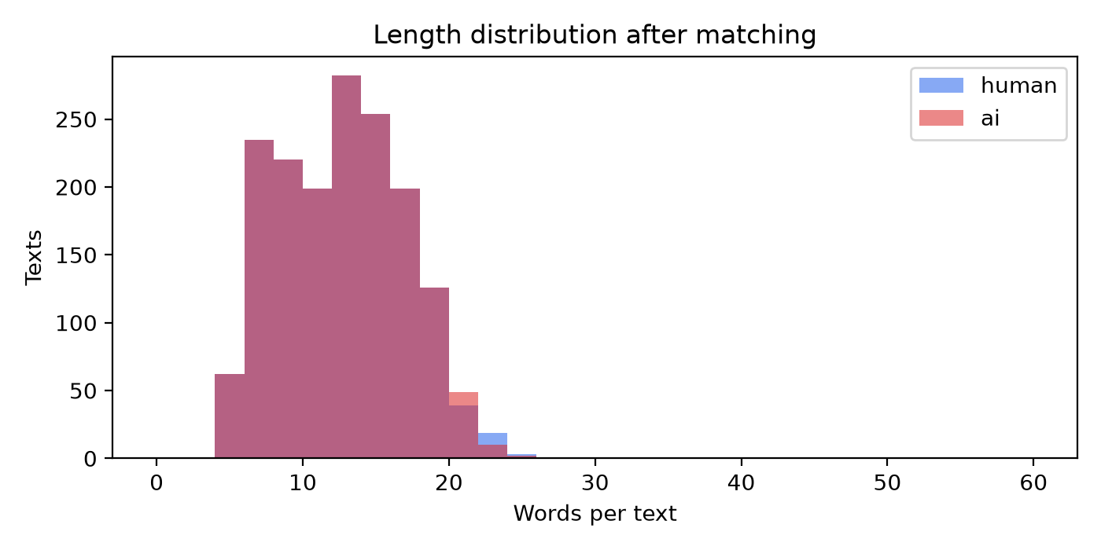
Figure 1. Word-count distribution of human vs. AI texts after length matching.

4. Methods

4.1 Feature extraction
Besides word (1–2 gram) and character (2–5 gram) TF-IDF features, 14 hand-built stylometric features target properties specific to Banglish and to AI-generated text generally: Banglish/English word ratio, code-switch rate (how often consecutive words alternate language), an informal-spelling-variant ratio (built from a hand-curated list of common Banglish spelling variants, e.g. valo/bhalo/vlo), punctuation and repeated-punctuation rate, emoji rate, word elongation ("sooo"), and sentence length, among others.

4.2 Models
Two detector families were trained and compared:
- Classical (deployed): word n-grams + character n-grams + the 14 stylometric features, feeding a logistic regression classifier (scikit-learn FeatureUnion + LogisticRegression, class-balanced).
- Transformer (comparison): XLM-RoBERTa base, fine-tuned on the same training split, trained on a Colab T4 GPU.
The classical model was chosen for deployment: on this dataset it matches the transformer's accuracy, runs on free CPU hardware (no GPU needed for inference), and — because it is linear — its explanations can be computed exactly rather than approximated.

4.3 Explanations
For the deployed linear model, SHAP values are computed in closed form: for a linear model with feature independence, the SHAP value of feature j is coef_j × (x_j − mean_j). Word- and character-n-gram contributions are mapped back onto the words of the original text so each word gets a signed score (red = pushes toward "AI", blue = pushes toward "human"); stylometric feature contributions are reported by name in a bar chart. For the transformer, Integrated Gradients (via Captum) gives an approximate, comparable attribution.

4.4 System and deployment
The pipeline runs end-to-end in a single Colab notebook: data cleaning and length-matching → train/val/test split → classical and transformer model training → explanation and faithfulness tests → figures and demo artifacts. The deployed demo is a Gradio app (banglishcheck.py + explainer.joblib) on a free Hugging Face Space; a second, standalone FastAPI version of the same app exists for deployment on a self-hosted domain.
Tech stack:
Part | Tools
Data and features | Python, pandas, regular expressions, custom Banglish word lists
Classical models | scikit-learn (TF-IDF, FeatureUnion, LogisticRegression)
Explanations | Linear SHAP (exact), Captum Integrated Gradients
Transformer | Hugging Face Transformers, XLM-RoBERTa base, Google Colab T4 GPU
Demo | Gradio 6 on Hugging Face Spaces, and a standalone FastAPI version

5. Results
On a held-out test set of 492 texts (246 human, 246 AI), the full classical model substantially outperforms either feature family alone, and matches the transformer:
Model | Accuracy | AUROC | AI caught at 5% false flags
Length only | 61.0% | 0.679 | 16.3%
Style features only | 87.4% | 0.942 | 72.8%
Word n-grams + LR | 96.1% | 0.995 | 97.2%
Char n-grams + LR | 97.4% | 0.998 | 98.8%
Full classical (deployed) | 96.5% | 0.996 | 99.6%
XLM-R (fine-tuned) | TODO | TODO | TODO
[[FILL IN: run the Colab notebook and paste the XLM-R row from outputs/results/model_comparison.csv, or keep XLM-R as future work and say so explicitly.]]
"AI caught" is measured at a decision threshold chosen so that only 5% of human validation texts are flagged — i.e., it reports how much AI text is caught while keeping false accusations of real people rare. The character-n-gram model alone is nearly as strong as the full model, suggesting most of the signal is in spelling/character-level patterns rather than word choice or style features in isolation — though the full model still gives the best AI-catch rate and, importantly, the richer explanations (Section 6).
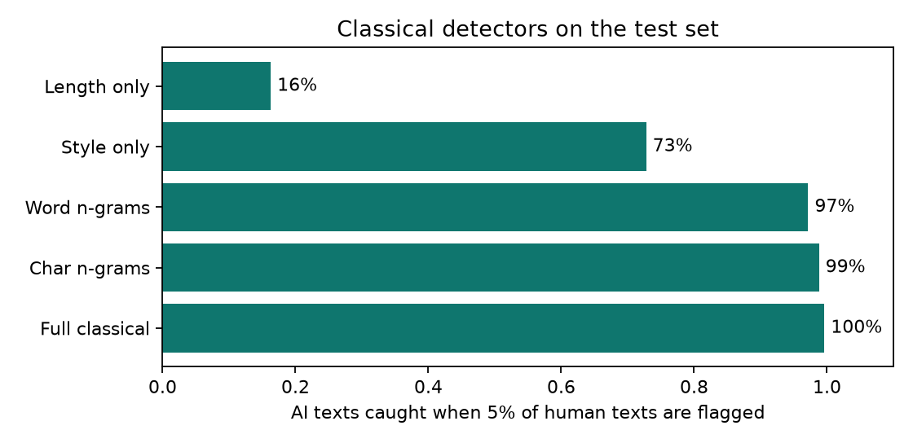
Figure 2. Accuracy and AUROC across feature combinations.

6. Explanations
Beyond accuracy, a goal of this project was to make sure the model's stated reasons are faithful to what it actually used — not just plausible-sounding. A deletion test checks this directly: deleting the five words the explainer ranks highest (by absolute SHAP value) drops the model's predicted confidence by 0.45 on average, versus only 0.15 when five random words are deleted instead. The roughly 3× gap shows the highlighted words are genuinely load-bearing for the prediction, not decorative.
Looking at which stylometric signals matter most globally (Figure 3), human reviews tend to use repeated punctuation ("..", "!!"), informal spelling variants, and emoji; AI-generated reviews tend to use tidier punctuation and somewhat longer words and sentences. This matches an intuitive expectation — informal, imperfect writing habits are harder for current generators to imitate than clean grammar — and gives a second, independent signal beyond raw lexical overlap.
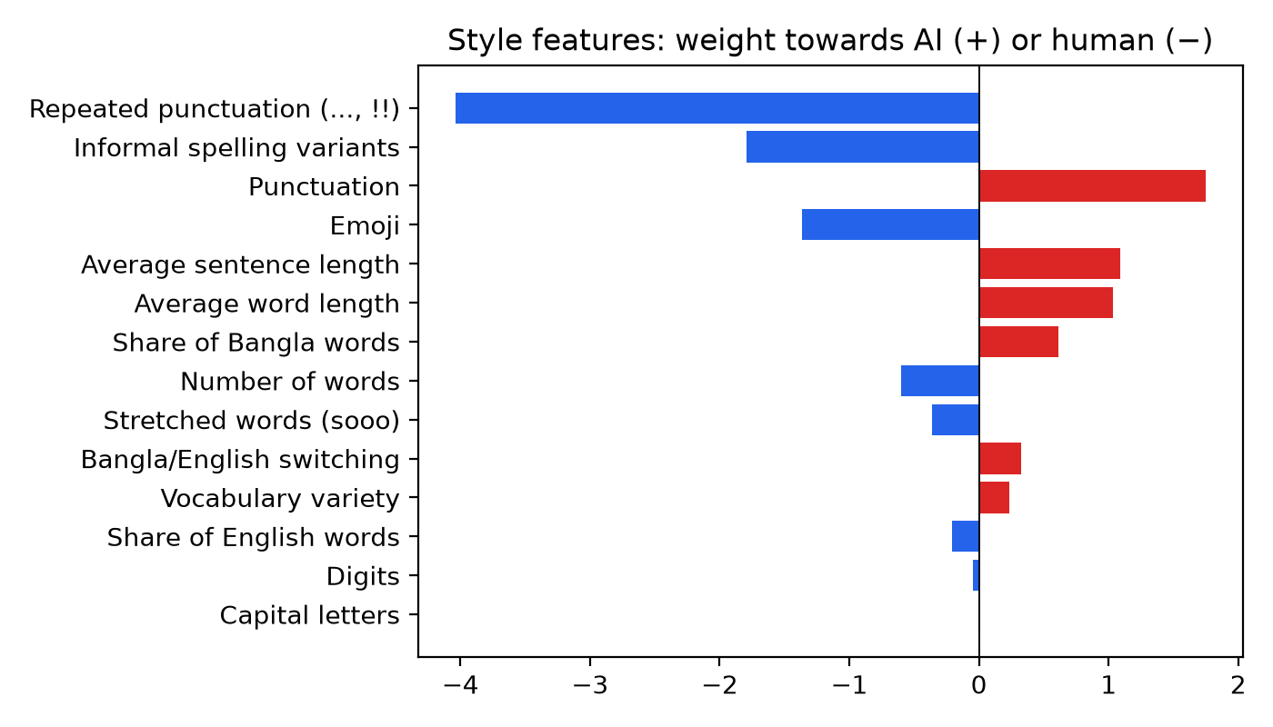
Figure 3. Writing-style signals, ranked by contribution to the AI/human decision.
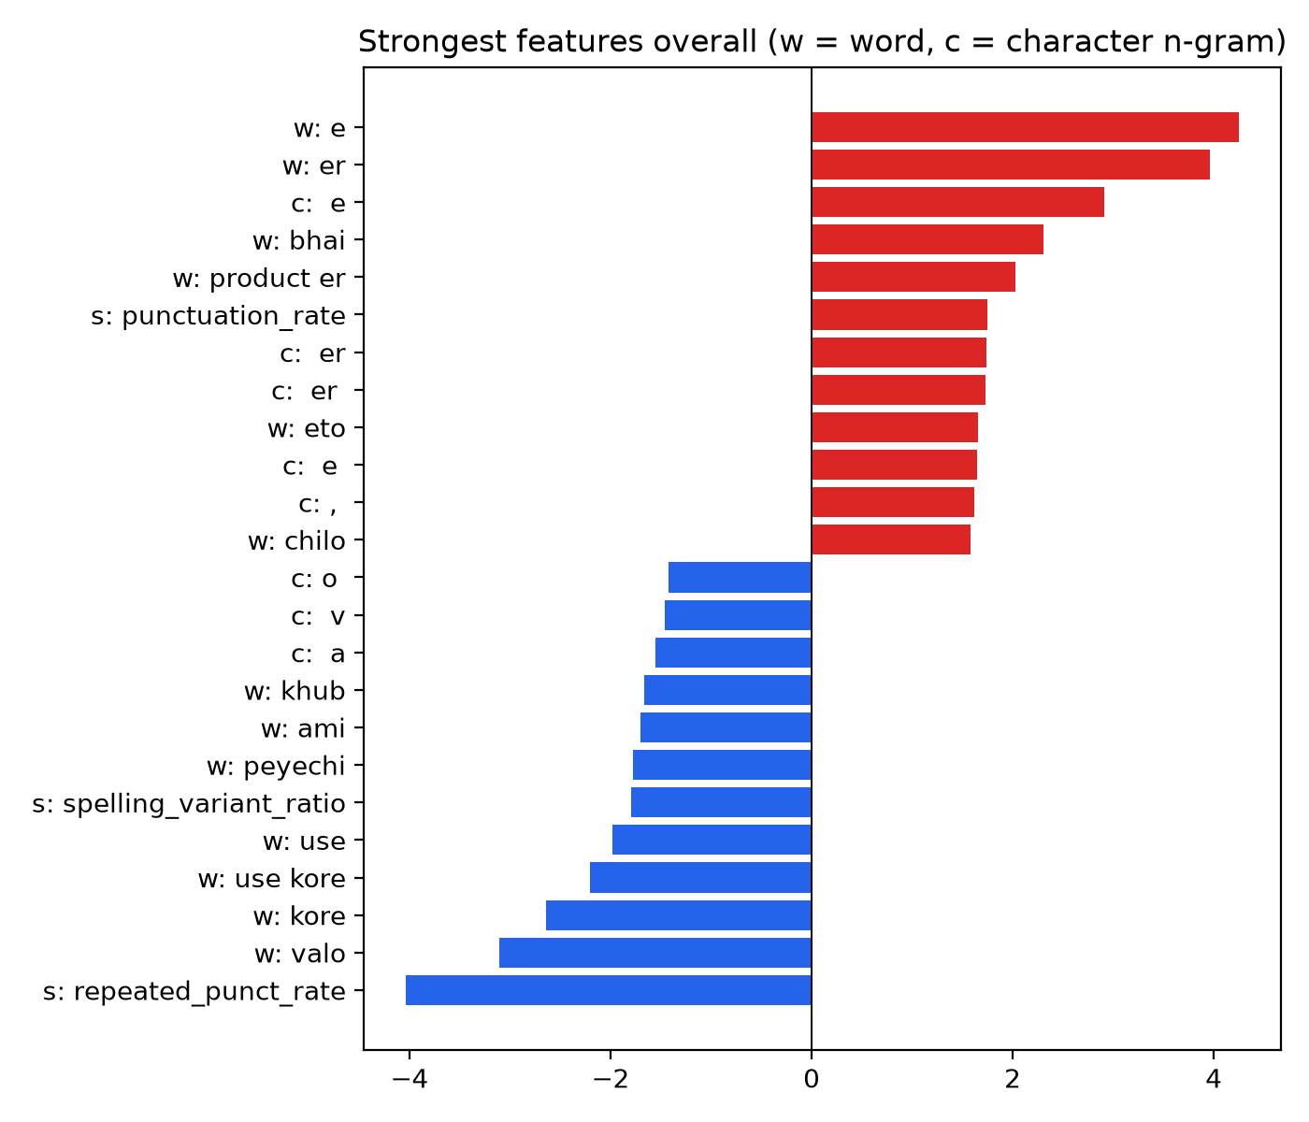
Figure 4. Top word/character features by model coefficient.

7. Robustness
A natural concern for any supervised AI-text detector is generalization to AI models it was not trained on — new generators appear constantly, and a detector trained on a fixed set of them should not be trusted blindly on new ones. A leave-one-generator-out test trains on two of the three AI generators and tests on the held-out third:
Left-out generator | AUROC | AI caught at 5% false flags
Claude | 0.938 | 61.0%
ChatGPT | 0.978 | 91.1%
Gemini | 0.996 | 99.5%

The detector's accuracy drops sharply when Claude is the held-out generator — AUROC falls from 0.996 on the main test set to 0.938, and the AI-catch rate at the 5% false-flag threshold drops from 99.6% to 61.0%. This is the project's clearest limitation: the detector generalizes well to ChatGPT- and Gemini- style writing it has never directly seen, but Claude's Banglish style appears to be distinct enough that unseen-Claude text is substantially harder to catch. In practice this means the detector should be retrained or re-validated whenever it needs to cover a new or updated AI model, and its score should never be treated as proof against a generator it was not validated on.
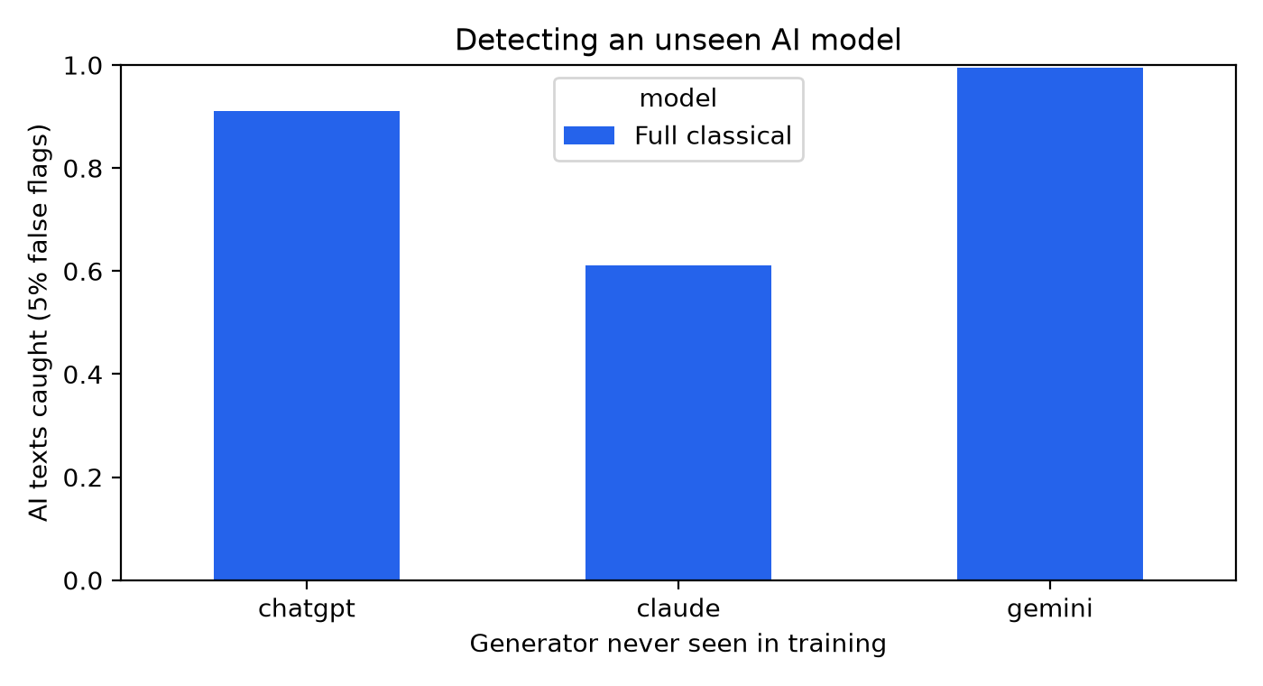
Figure 5. AUROC and AI-catch rate when each generator is held out of training.

8. Limitations and Future Work
- The human-text side of the dataset is entirely product reviews; the model's reliability on other genres of Banglish writing (chat, social media, essays) is untested.
- Texts under roughly 8 words give unreliable predictions, and the deployed app warns the user about this directly.
- Paraphrased or lightly human-edited AI text has not been tested; this is a realistic adversarial case the current evaluation does not cover.
- Only 188 Gemini texts were available, the smallest of the three AI sources — more data per generator, and from more generators, would make both the accuracy numbers and the robustness test more reliable.
- As shown in Section 7, the detector generalizes unevenly across AI generators and should not be assumed to work on a generator it has not been validated against.
[[FILL IN: Add your own reflection here: what would you prioritize first if you continued this project — more data, more generators, testing against paraphrasing attacks, or something else — and why?]]

9. Ethics
An AI-text detector carries real risk of harm if misused: a false positive can be used to wrongly accuse a real person of using AI, with consequences ranging from a failed assignment to reputational damage. This project treats that risk as a design constraint rather than a footnote: the deployed app always displays a notice that the score is an estimate, can be wrong, and must never be used on its own to accuse anyone of using AI; it separately flags short texts (under 8 words) as unreliable; and every prediction is shown together with its evidence (highlighted words and style signals) specifically so a human reviewer can sanity-check the model rather than deferring to it.
The same transparency goal motivated the faithfulness test in Section 6 — an explanation that is not demonstrably tied to the model's actual behavior would be worse than no explanation at all, since it could lend false credibility to a wrong decision.

References
Shamael, M. N., Nawshin, S., Shatabda, S., and Islam, S. (2024). BanglishRev: A Large-Scale Bangla-English and Code-mixed Dataset of Product Reviews in E-Commerce. arXiv:2412.13161.
Conneau, A., Khandelwal, K., Goyal, N., Chaudhary, V., Wenzek, G., Guzmán, F., Grave, E., Ott, M., Zettlemoyer, L., and Stoyanov, V. (2020). Unsupervised Cross-lingual Representation Learning at Scale. ACL 2020.
Lundberg, S. M., and Lee, S.-I. (2017). A Unified Approach to Interpreting Model Predictions. NeurIPS 2017.
Sundararajan, M., Taly, A., and Yan, Q. (2017). Axiomatic Attribution for Deep Networks. ICML 2017.
Abid, A., Abdalla, A., Abid, A., Khan, D., Alfozan, A., and Zou, J. (2019). Gradio: Hassle-Free Sharing and Testing of ML Models in the Wild. arXiv:1906.02569.

